**Project Report**

Done by: Pratik Pranav

-3rd year student of GEC Goa ( IT Engineering )

AIM : To create a web application that utilizes HTML/Bootstrap, PHP, jQuery, MySQL, and handles form submissions.

Objective : This project gives an hands-on experience in building a dynamic website with server-side scripting, database integration, and client-side interactivity.

Software Requirements and steps to run the code :

1. Any editor for running the code (eg. VS code)
2. Xamp software for database connectivity (mysql)

Here I have used four codes named :

1. Index.html (html code)
2. Form.css (css code)
3. valid.js (javascript code)
4. data.php (php code)

*\*Put these 3 codes in a folder and put that folder in htdocs of xamp folder to run the phpMyAdmin for databases.*

*\*\*First of all, start the Apache and Mysql from Xamp to run the phpMyAdmin on the browser. (localhost/foldername/filename)*

Project highlights and Features :

This is the project of form details submission wherein you can enter your details such as :

First name , Last name ,Phone Number , Gender , Marital Status and Address.

And all this data of the user can be submitted through a submit button which is then stored in the database on localhost. (phpMyAdmin and mysql)

The table in the database also contains all the fields as columns and the same is stored in it.

So this project can be used to get and store user data from various users.

Challenges faced in the Project :

*Html and css was completely known to me so I did not faced any difficulties in it , php also I knew the basics so with a quick revision I could do the task given along with the phpMyAdmin connection.

*I faced the difficulties in javascript and jquery *to implement the various restrictions in the input field of the html* tags that were mentioned in the task given .

As it was something *new to me as it was neither done in college nor I had learnt from any sources.*

But *with my interest , dedication towards the project completion and my continuous efforts* I could find some help from internet and could solve some of the tasks which I could not do on my own.

*I also faced some difficulties in preparation of the document as till now I have no experience of making a project document to give to a company, but I do completed the task with my intelligence and knowledge.

Project Requirements:

Front-End Development:

* Create a visually appealing user interface using HTML and CSS.
* Implement client-side interactivity and dynamic behavior using jQuery.
* Design and validate a user-friendly form for data input.

Form should include

1) Enter first name (text – should not contain special character and must be

greater the 3 character )

2) Enter Last name (text – should not contain special character and number and

must be greater the 3 character )

3) Enter Phone No (text – should not contain special character and alphabet and must be greater the 3 character )

4) Select Gender (radio button)

5) Select marital status (select box)

6) Enter address text – (should not contain special character and must be greater than 20 and less than 150 character

7) Submit button (for submitting the data)

Back-End Development:

* Develop the server-side functionality using PHP.
* Establish a connection to a MySQL database for data storage and retrieval.
* Implement form submission handling and data processing.
* Set up a MySQL database to store user-submitted data.
* Create necessary tables and fields to store form data accurately.

**Codes :**

Index.html :

<!DOCTYPE html>

<html lang="en">

<head>

    <meta charset="UTF-8">

    <meta name="viewport" content="width=device-width, initial-scale=1.0">

    <title>Document</title>

    <link rel="stylesheet" href="form.css">

    <link rel="stylesheet" href="valid.js">

</head>

<body>

    <script> //jquery for phone no text

       function numonly(input)

       {

        var num = /[^0-9]/gi;

        input.value = input.value.replace(num,"");

       }

    </script>

    <div class="container">

        <form action="data.php" method="post"  onsubmit="return myfunc()">

            <h1 style="margin: 5px 50px 10px;">Submit Form</h1>

            <label for="fnl">Enter First Name</label>

            <input type="text" id="fnt" name="fnt" value=""  required><br>

            <span id="fnm"> </span><br>  <!--  to display message for errors in textboxes -->

            <label for="lnl">Enter Last Name</label>

            <input type="text" id="lnt" name="lnt" value="" ><br>

            <span id="lnm"> </span><br>

            <label for="pnl">Enter Phone No:</label>

            <input type="tel" id="pnt" name="pnt" onkeyup="numonly(this)"  required><br>

            <p>Select Gender

            <p>

                <input type="radio" id="male" name="gender" value="Male" required>

                <label for="male">Male</label>

                <input type="radio" id="female" name="gender" value="Female">

                <label for="female">Female</label><br>

            <p>Select Marital status

            <p>

                <select name="mas" id="mas" required>

                    <option value="married">Married</option>

                    <option value="Single">Single</option>

                    <option value="Widow">Widow</option>

                </select><br>

                Enter Address :

                <textarea name="ta" id="ta" rows="5" cols="25" placeholder="Please enter the text between 20 to 150 characters only"></textarea><br>

                <br>

                <button type="submit" name="sb" value="submit">Submit</button>

        </form>

    </div>

</body>

</html>

form.css :

*{

    box-sizing: border-box;

}

body{

    background-color: rgb(202, 238, 238);

}

.container{

    border: 2px solid black;

    padding: 20px;

    margin: 20px 300px 0 300px;

    background-color: rgb(245, 217, 182);

    box-shadow: 0 0 5px 2px yellow;

    border-radius: 10px;

}

input{

    padding: 5px;

    margin: 10px ;

    border: 2px solid black;

    box-shadow: 0 0 5px 2px rgb(199, 199, 237);

    border-radius: 10px;

}

textarea{

    padding: 5px;

    /* margin: 10px ; */

    border: 2px solid black;

    box-shadow: 0 0 5px 2px rgb(199, 199, 237);

    border-radius: 10px;

}

button{

    margin: 5px 60px;

    padding: 5px;

    border: 2px solid black;

    box-shadow: 0 0 5px 2px rgb(199, 199, 237);

    border-radius: 10px;

    cursor: pointer;

}

valid.js :

function myfunc(){

    //for first name textbox

    var fn = document.getElementById("fnt").value; //gets the fnt textboxs value and stores in fn

    var ch1 = /^[A-za-z]+$/; //only character are allowed

    if(fn==""){ //if empty

        document.getElementById("fnm").innerHTML="*Please fill username";

        return false;   //.innerhtml overrides the message ie it will write the message over there where elemnt id is fnm

    }

    else

    if(fn.length<=3)  {  //length of array what user will enter its length

    document.getElementById("fnm").innerHTML="*name must be greater than 3 characters";

    return false;

    }

if(fn.match(ch1)) //if fn(textbox value) matches the ch1 (characters)

true;

else{

    document.getElementById("fnm").innerHTML="*only alphabet is allowed";

    return false;

}

  //for last name textbox ----------------------------------------------

  var ln = document.getElementById("lnt").value;

  var ch2 = /^[A-za-z]+$/;

  if(ln.length<=3)  {  //length of array what user will enter its length

  document.getElementById("lnm").innerHTML="*name must be greater than 3 characters";

  return false;

  }

if(ln.match(ch2))

true;

else{

  document.getElementById("lnm").innerHTML="*only alphabet is allowed";

  return false;

}

}

Data.php :

<?php

if(isset($_POST["sb"])){  //if sb ie submit button is pressed then only ....

     $server = "localhost";

     $username = "root";

     $password = "";

     $connect = mysqli_connect($server,$username,$password);  //database connection

    //  if ($connect->connect_error) {

    //     die("Connection failed: " . $connect->connect_error);

    // }

    if(!$connect){     //function to check if connection is success or not

        die("connection to database failed due to " . mysqli_connect_error());}

    $fname = $_POST["fnt"];

    $lname = $_POST["lnt"];    //retreiving data from the textboxes

    $pno = $_POST["pnt"];

    $gender = $_POST["gender"];

    $mas = $_POST["mas"];

    $add = $_POST["ta"];

    $query = "INSERT INTO `formdata`.`submitform` (`fname`, `lname`, `phoneno`, `gender`, `martial status`, `address`) VALUES ('$fname', '$lname', '$pno', '$gender', '$mas', '$add');";

    $result = mysqli_query($connect,$query);

    if($result)

    {

        echo "data inserted successfully";

    }

    else{

        echo "data not inserted";

    }

}

?>

Outputs :

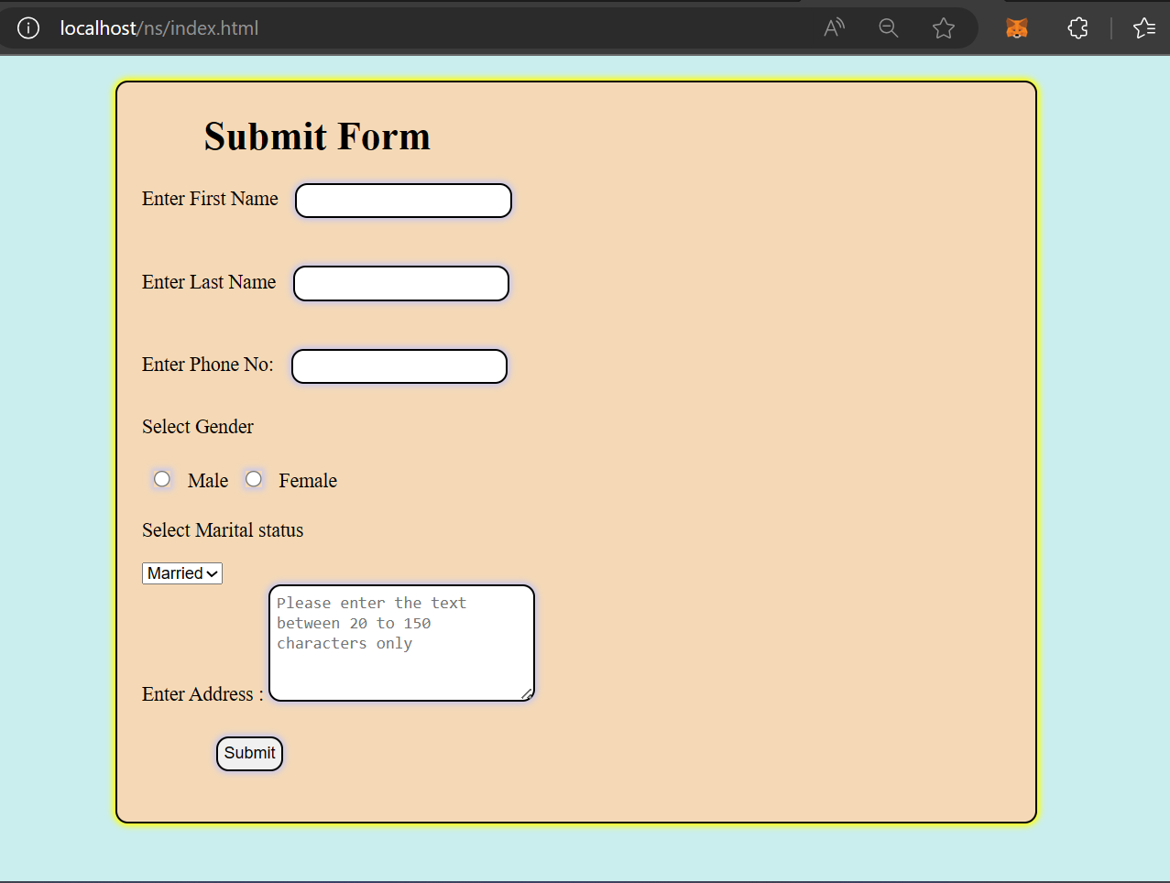

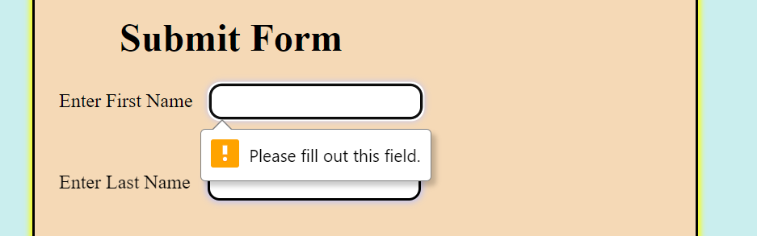

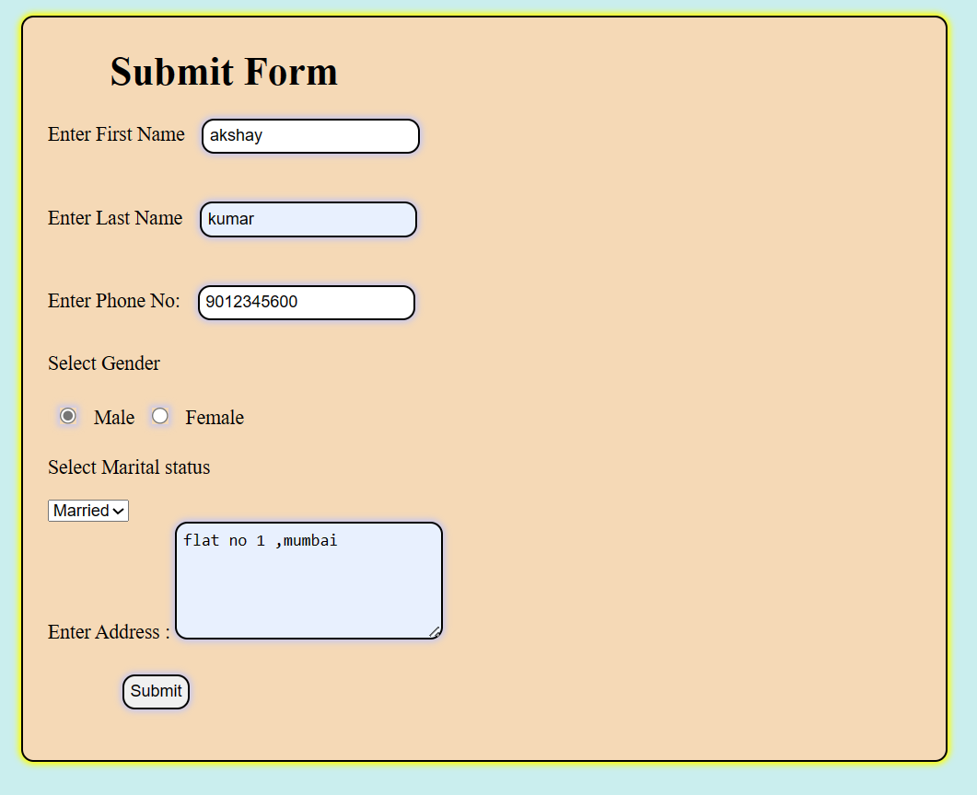

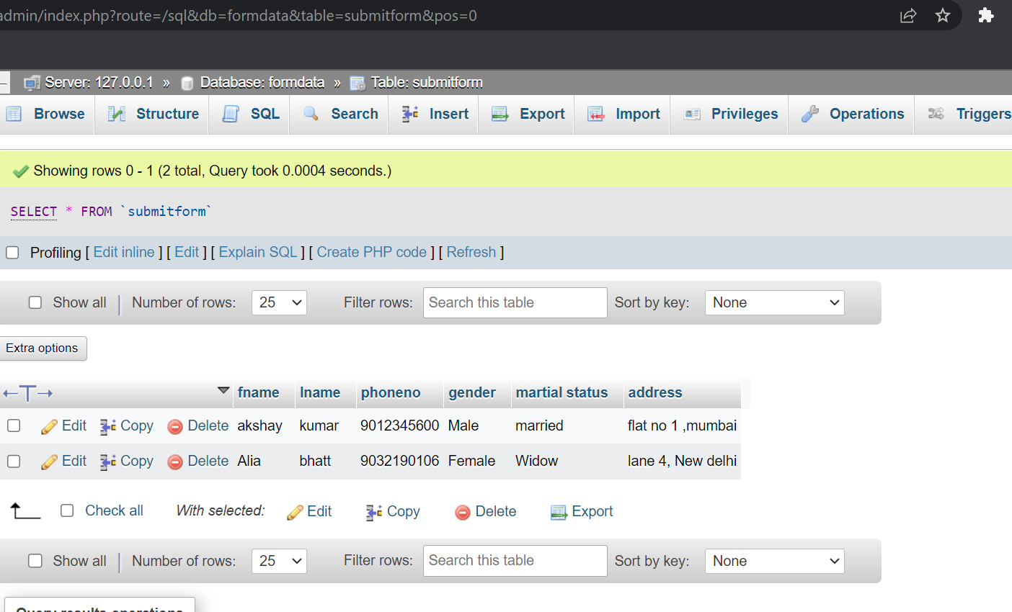

Conclusion : Successfully completed the given task to create a submit form for storing data in database using html, css , javascript and php.

References used :

1. Google.com
2. Youtube.com
3. Javatpoints
4. Geeksforgeeks

**Thank You**